Automation Framework Architect

1. Language: Java
2. Software project management and comprehension tool: Maven
3. Behavior Driven Development supporter: Cucumber
4. Generate report: net.masterthought
5. Test management: testng
6. Web automation testing framework: Selenium

Amazon Shopping structure

1. TestSuites: store file testng.xml to manage test suite runner

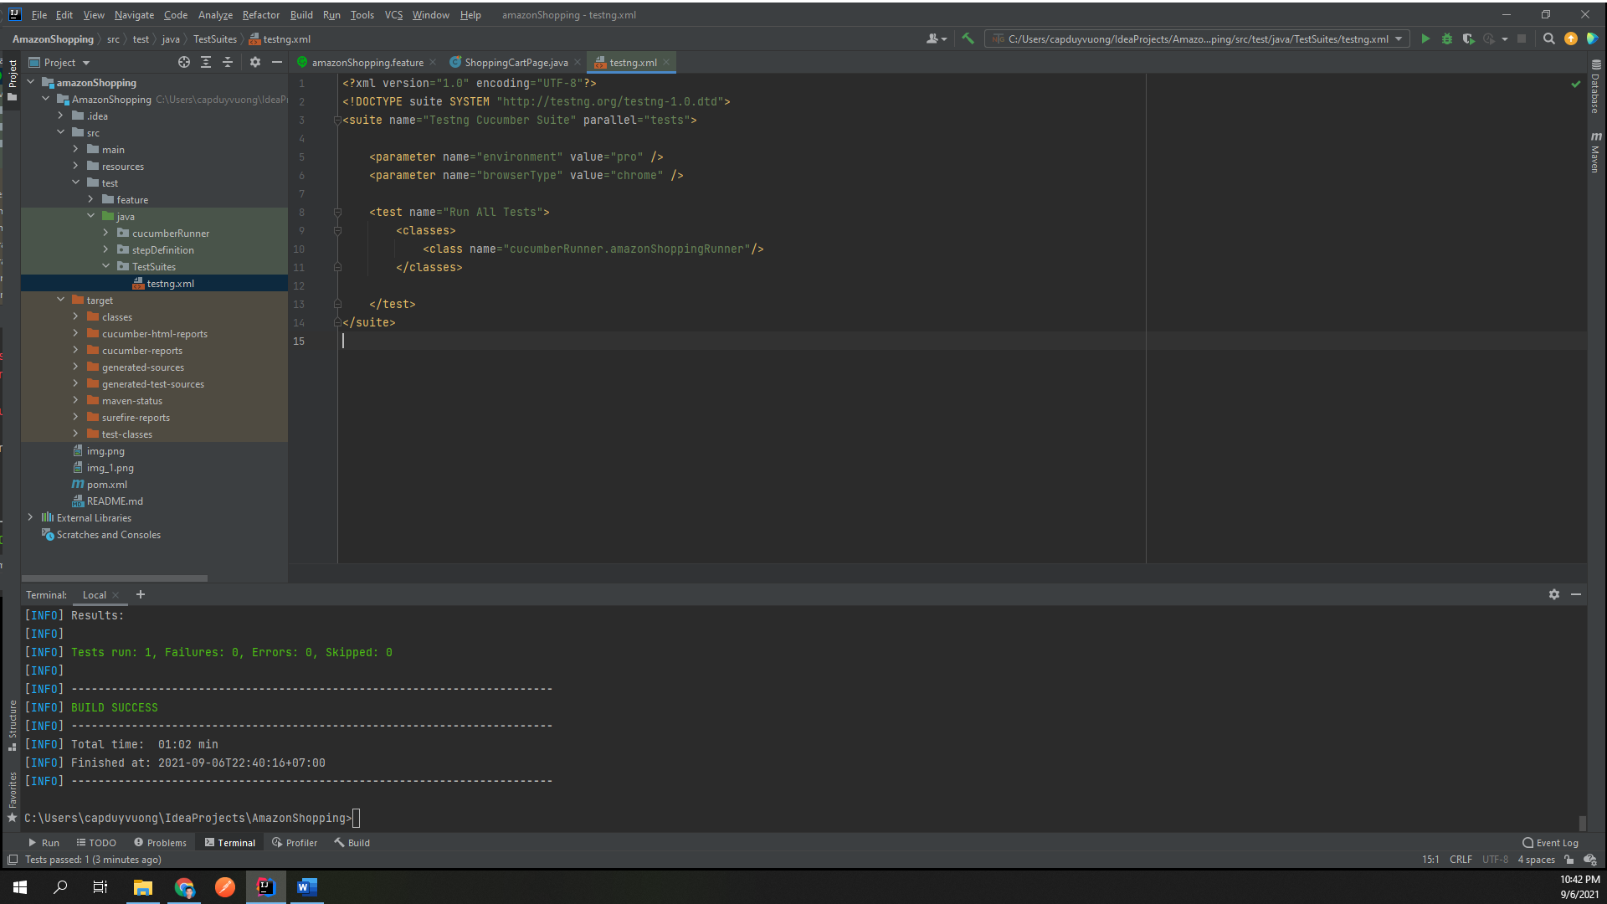

1. src/main/java/core: manage and control all of frameworks, libraries

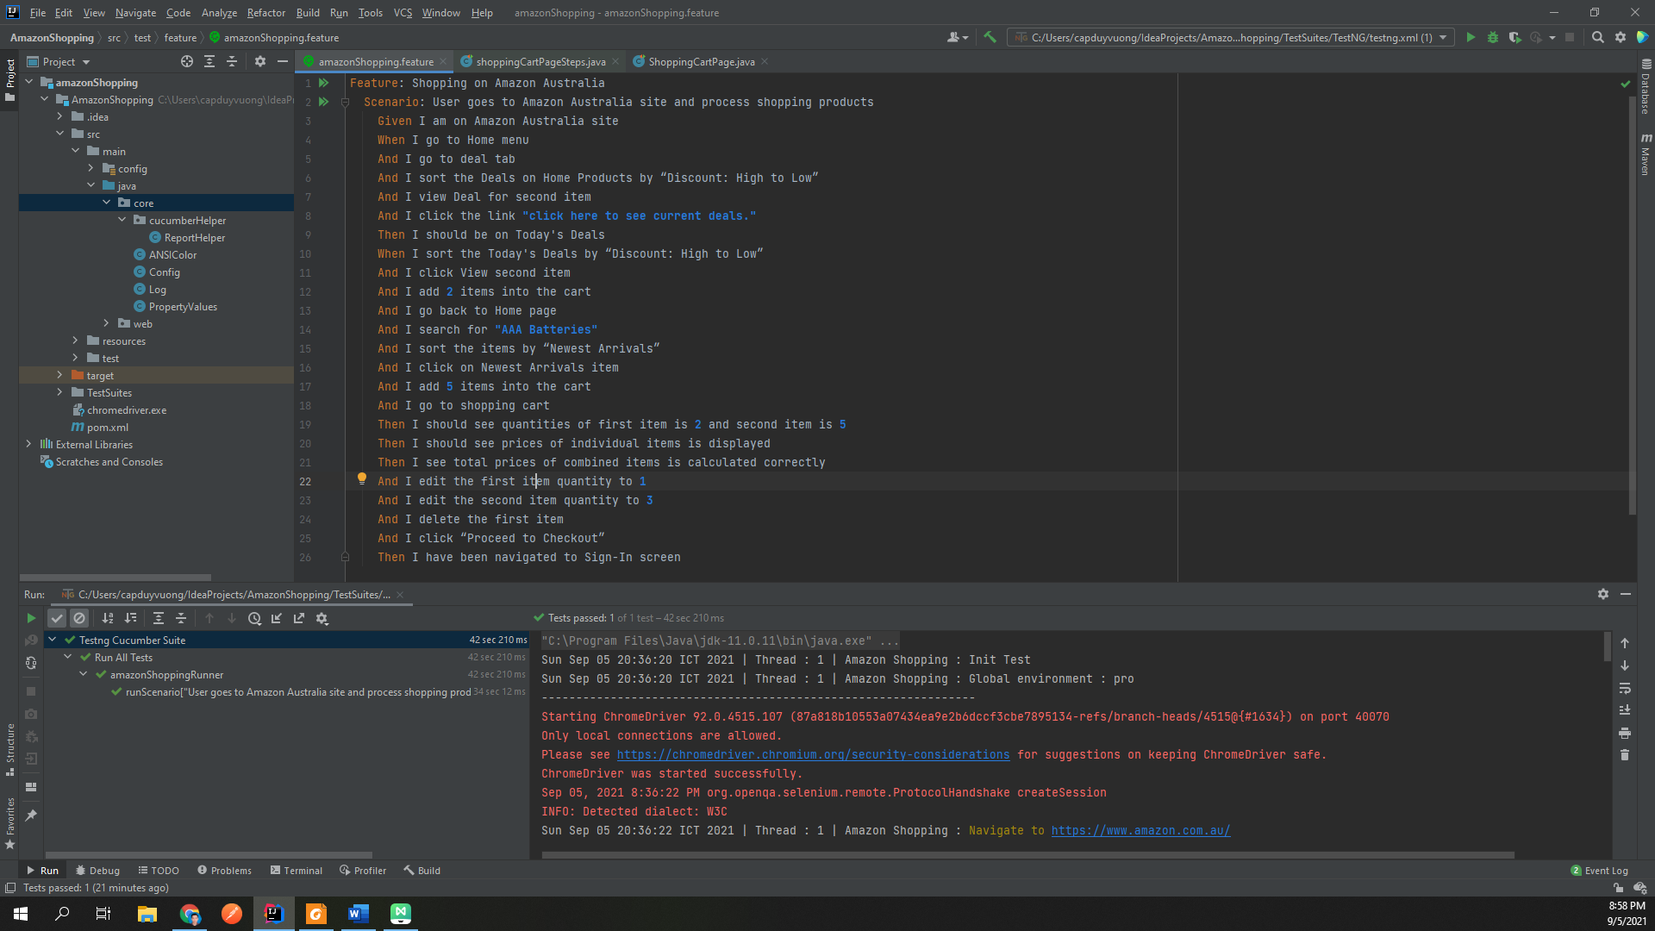

1. src/main/java/web: using Selenium framework to handle web testing
   1. web/objectPages: define elements on pages and actions on them
   2. web/SeleniumWebHelper: Setup Selenium, browser, and common function
   3. web/Timer: waiting for element, browser, page, …
   4. web/UIComponent: common function to control all components in a browser
   5. web/WebBaseTest: common setup for web testing

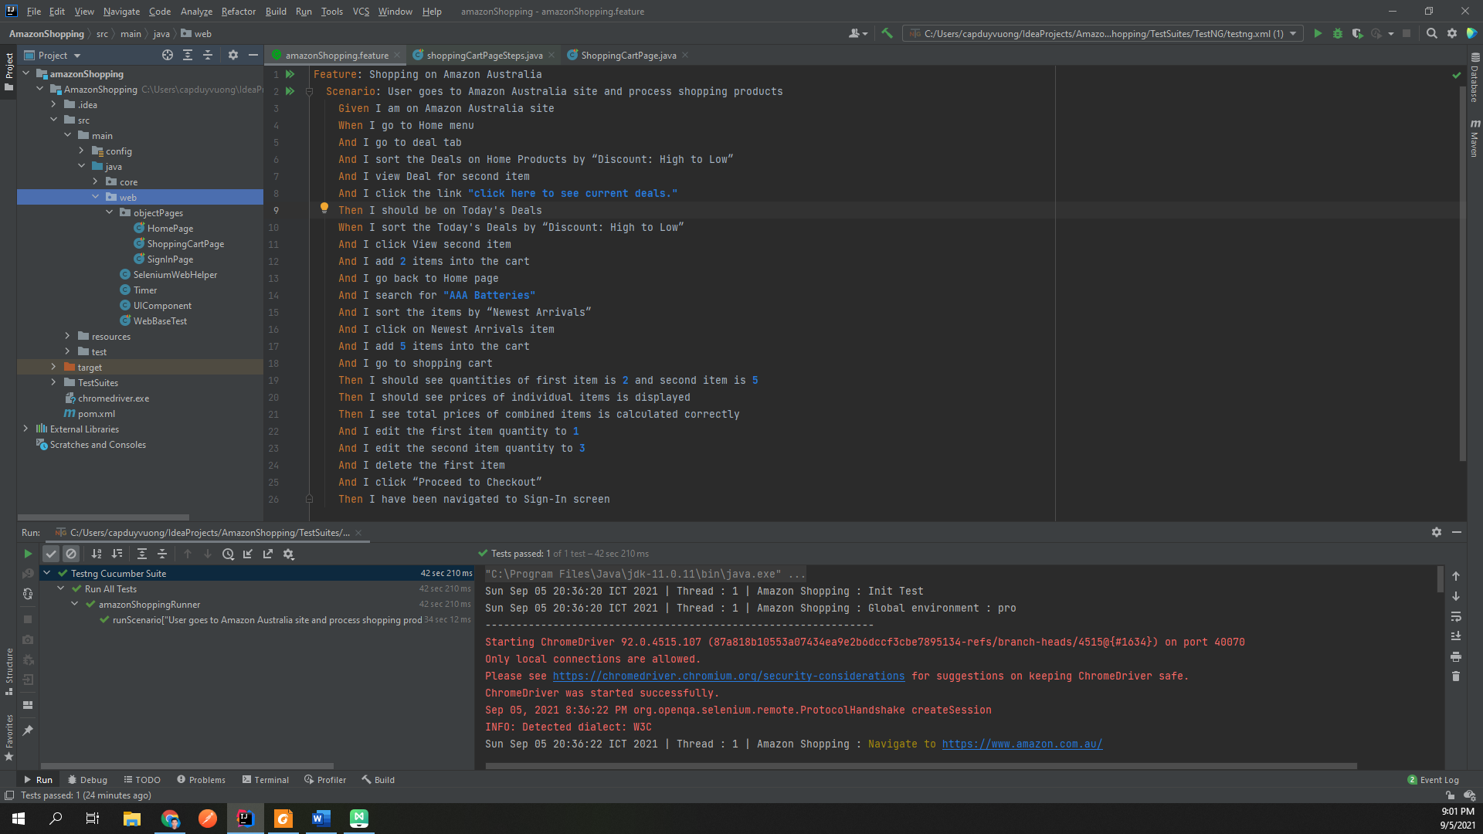

1. src/test/java/cucumberRunnercucumberRunner: setup Cucumber runner. File testng call cucumberRunner to execute test suite

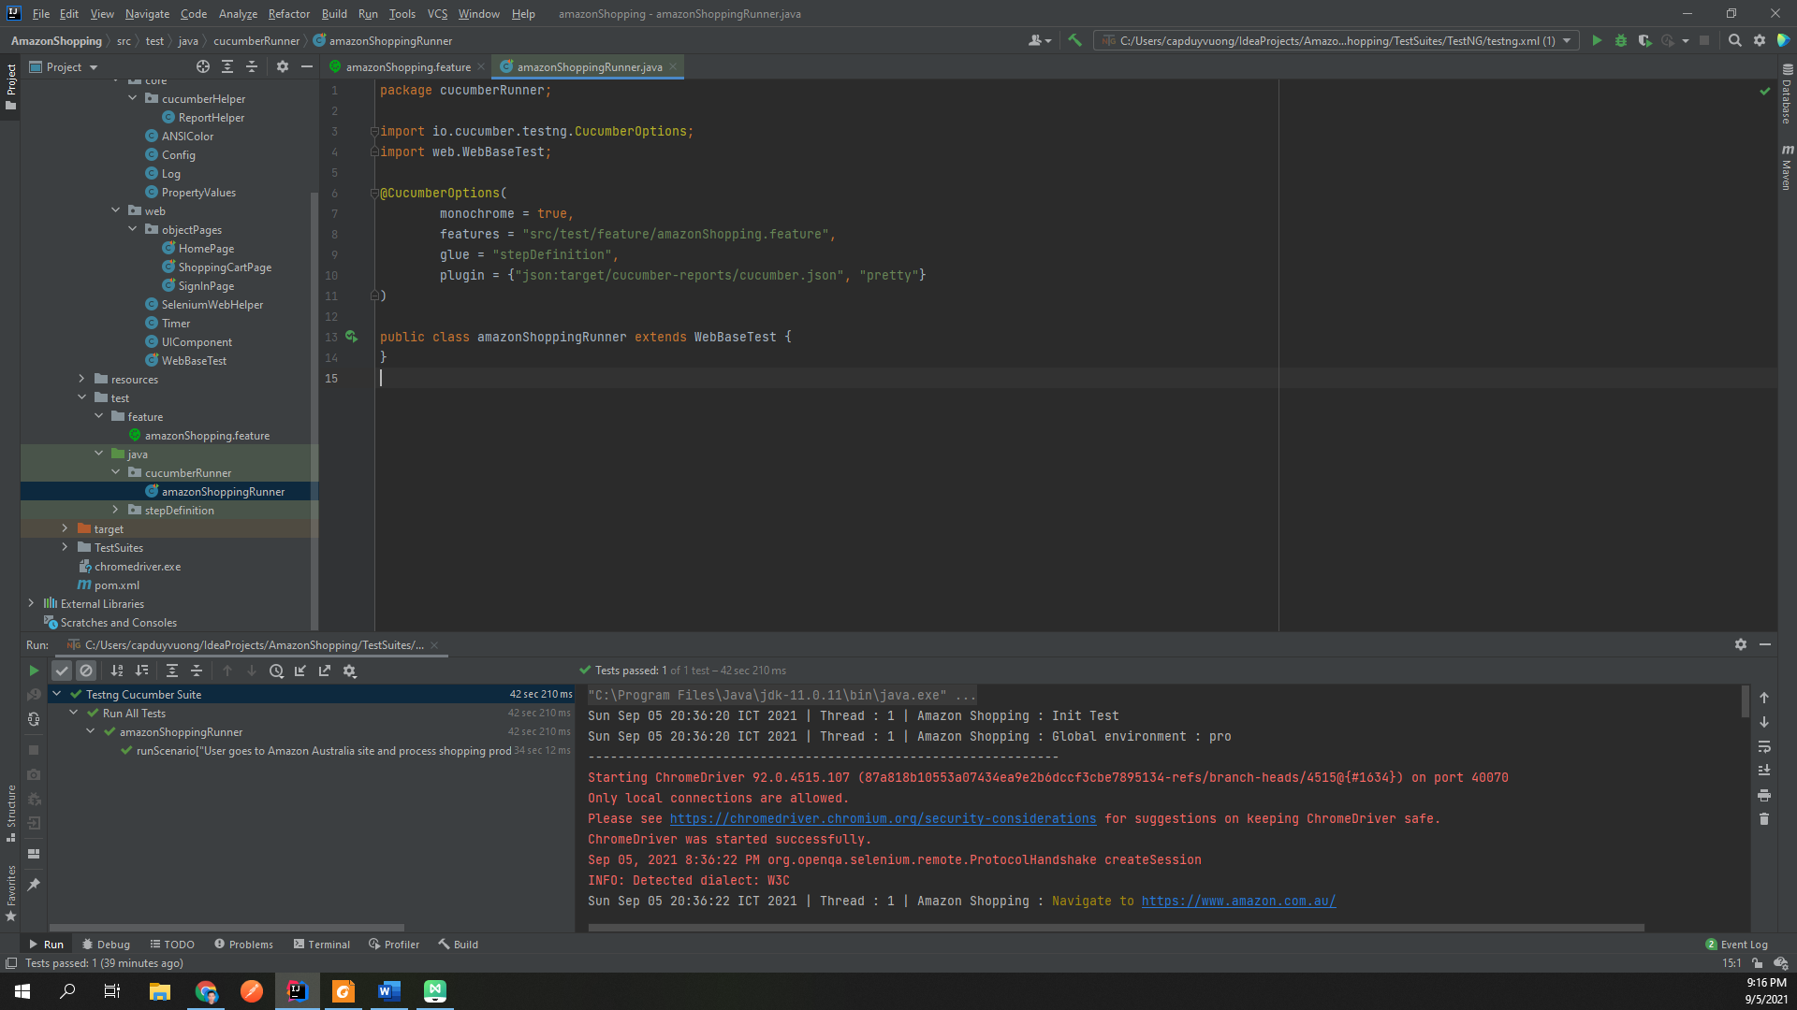

1. src/test/java/stepDefinition: define step of cucumber

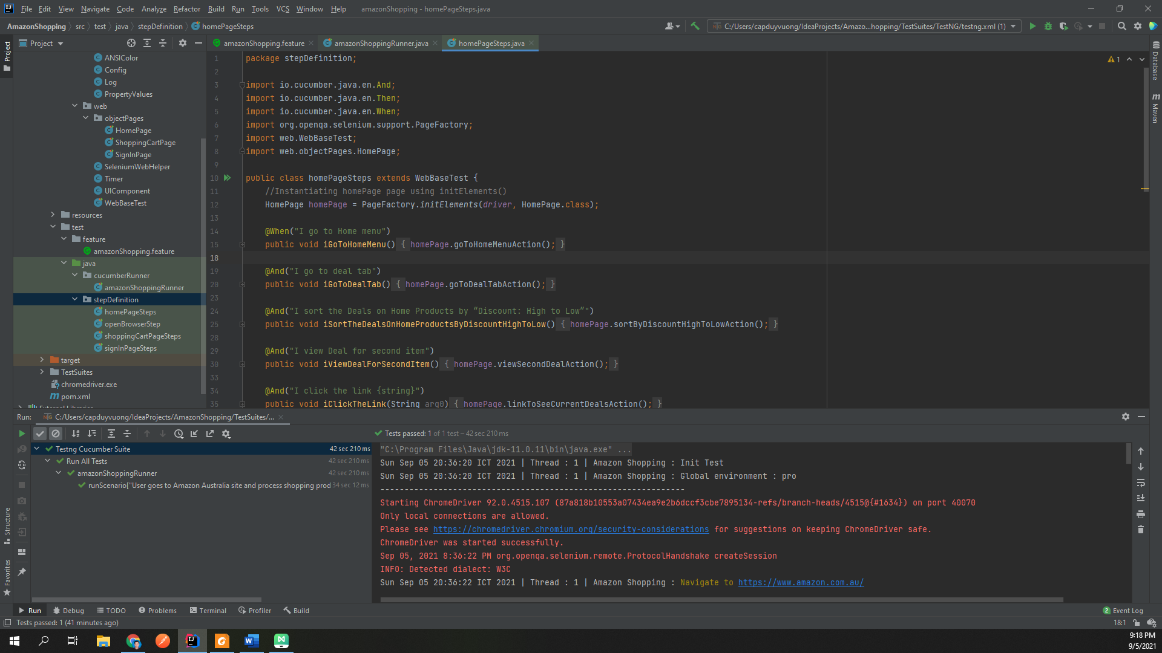

1. src/test/feature: store cucumber test suite file “.feature”

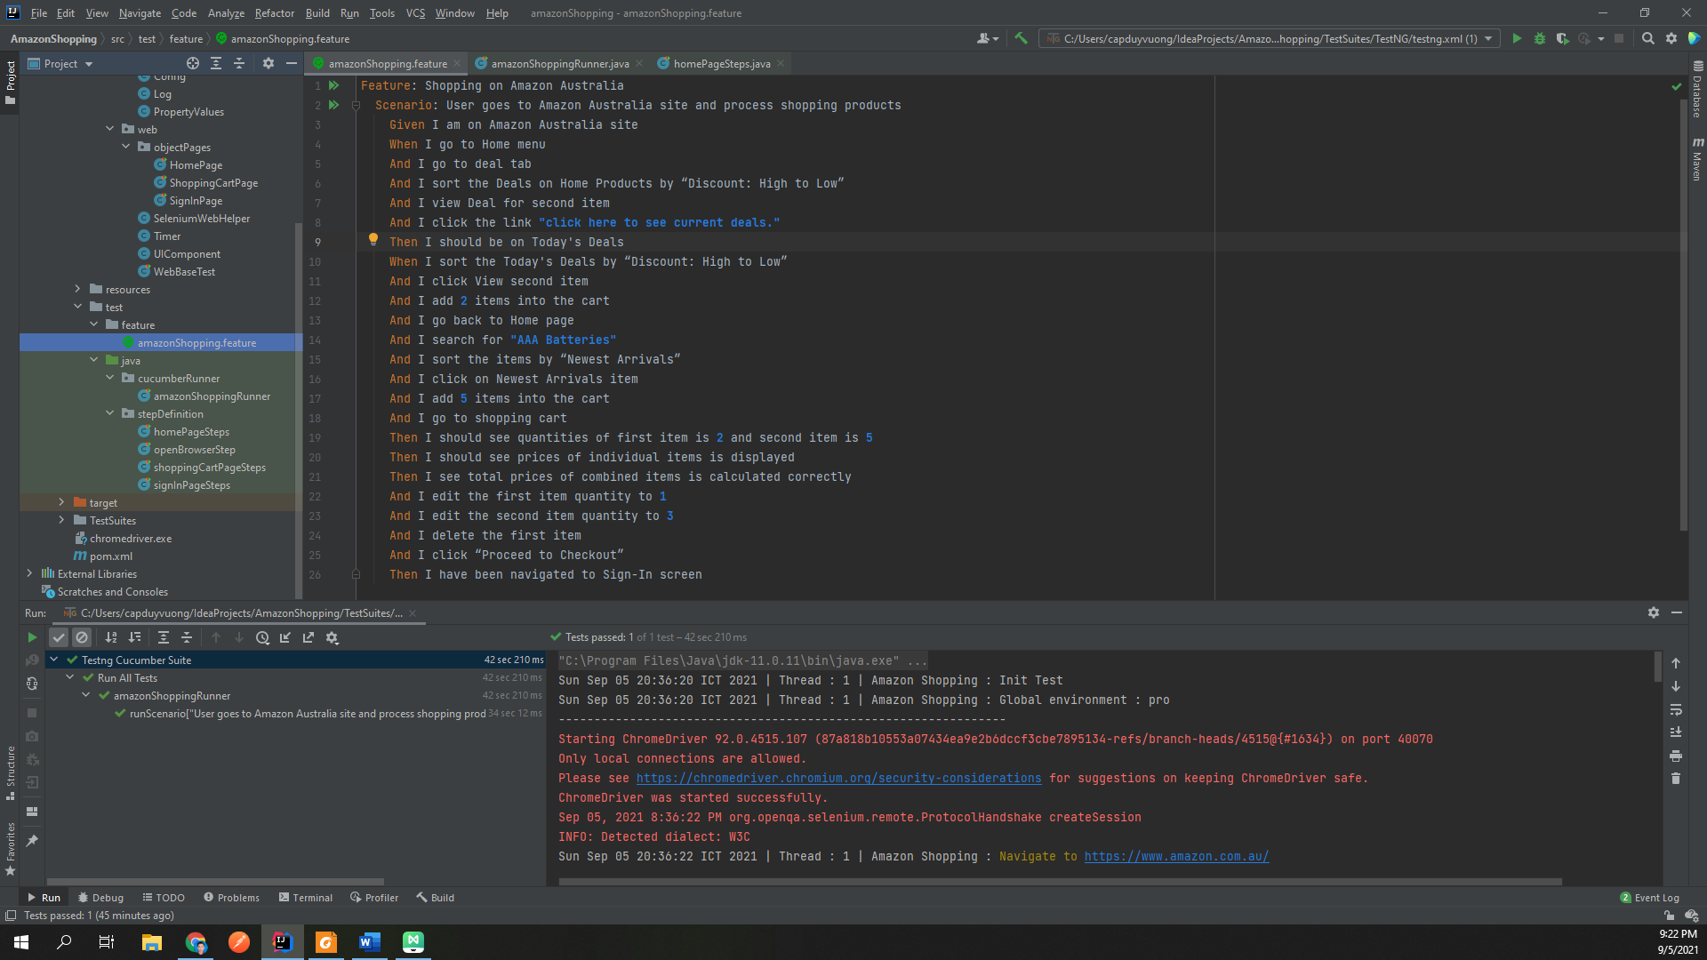

1. src/resources: resources for testing (store browser driver to run selenium)

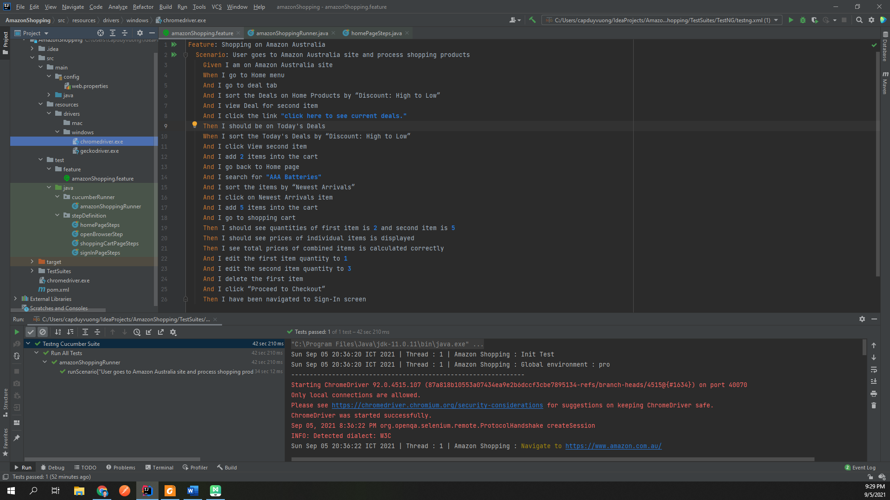

1. main/config/web.properties: store system, testing config

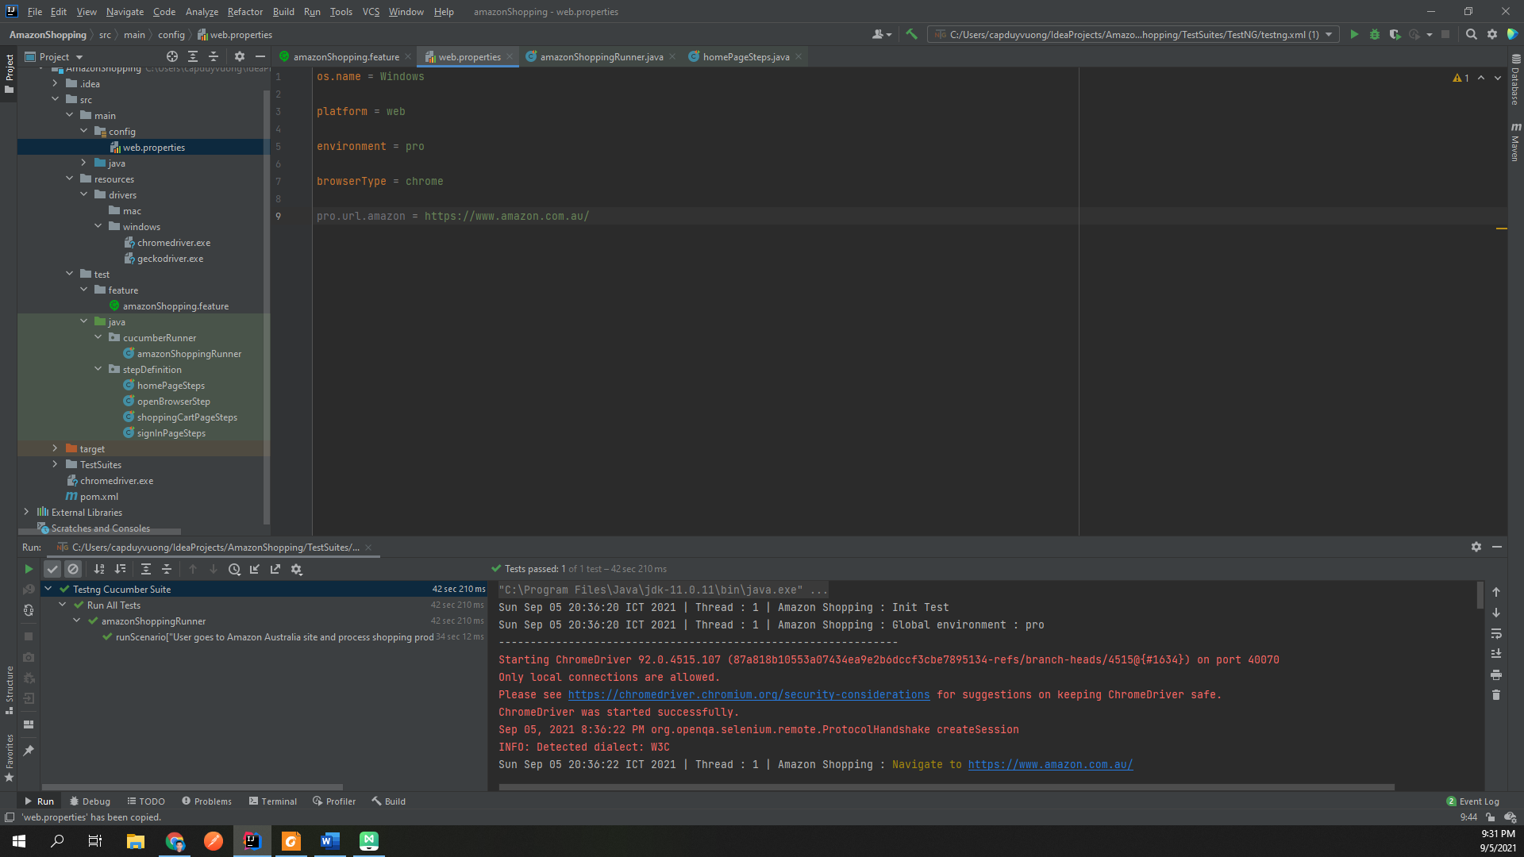

1. target: is generated by maven or report library

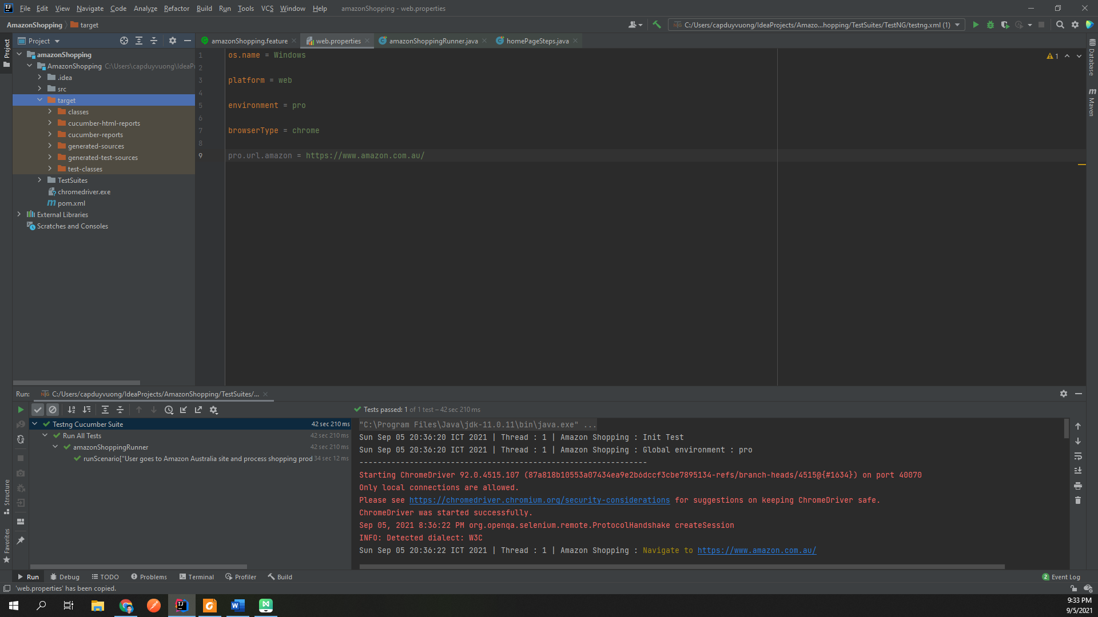

1. pom.xml: manage project dependencies, libraries, plugins, profile

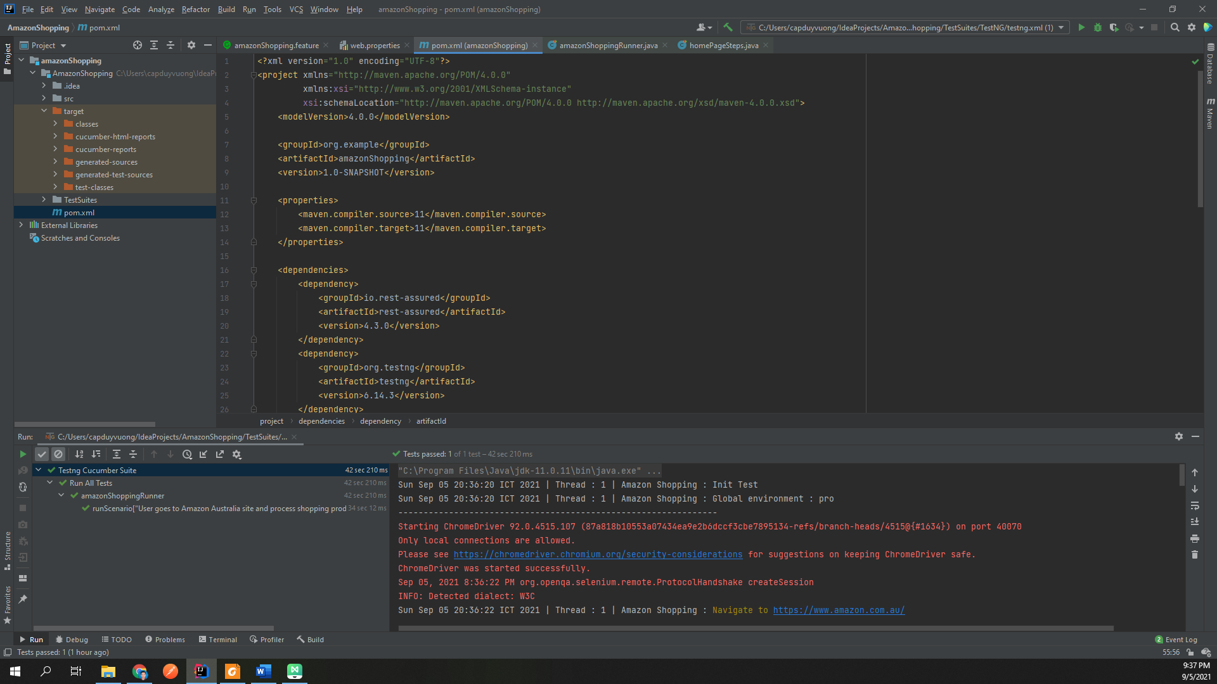

1. Readme.md: Guide to use project

